FAKE NEWS DETECTION USING ENSEMBLE LEARNING
Under the guidance of
Prof. Pushpendra Tyagi
Pushpendra.kumar@kiet.edu

Prashansa Rai
Computer Science Engineer

KIET GROUP OF INSTITUTIONS GHAZIABAD,INDIA

Prashansa.1923cs1174@kiet.edu

Mohd Naseem
Computer Science Engineer
KIET GROUP OF INSTITUTIONS GHAZIABAD,INDIA
mohd.1923cs1177@kiet.edu

Paras Jain
Computer Science Engineer
KIET GROUP OF INSTITUTIONS GHAZIABAD,INDIA
Paras.1923cs1106@kiet.edu

Abstract—
Over the recent years, the generation and exchange of news and information have rapidly risen with the emergence of technology. The major sources of news and information have been social media feeds, news websites, blogs, and articles. A significant part of this news is reportedly fake and unauthentic, which can be misleading and spread fake rumours in public. This fake news is intentionally propagated to damage the reputation of an individual or an organization. This paper tried to solve this issue by applying machine learning to detect and effectively dismantle disinformation.

I . INTRODUCTION
The arrival of the world wide web and the vast emergence of social media platforms has increased data availability and provided real-time news to people.
The news evolution from newspapers to the internet has been rapidly speedy in recent years [1]. However, sometimes disinformation is propagated with a hidden agenda issued by the political parties and wealthy and influential people for their harmful intention causing riots and communal disputes between people.
Consumers always have the latest news at their fingertips. A large percentage of news site traffic is recommended by Facebook [2]. These social media provide a platform for the user where they can share their ideas and do a brief discussion about various topics, such as healthcare, democracy, and education but some people use these opportunities in a negative perspective to spread hate in our society [3].
Various types of data available on the internet, like text, multimedia and hyperlinks, serve in different ways. These data might necessarily not be authentic as they are collected various unknown resources.
Our paper proposes a novel method and tool for detecting fake news that utilizes machine learning. We have used ensemble learning models, including multiple commonly used classifiers, and have shown promising results in the project.
A total of five classification models have been utilized to detect fake news: Naive Bayes [4], Logistic Regression, Random Forest, Support Vector Machine and Decision Tree. The primary aim of this research paper is to show the benefits of machine learning through different classifiers. These models have shown great accuracy (above 90%) in the results. classifiers to achieve the best accuracy and precision [5].

II.related work

In [10], the authors have proposed machine learning methods based on text processing. They have used Linguistic Inquiry and Word Count package to acquire features on provided texts on the dataset taken from Kaggle and from various prominent news agencies. Multiple Models have been used among which support vector machine gives the best result with 87% of accuracy.
The authors of [11] have done a survey about all kinds of fake news that propagate through social media and how they impact social media user in different ways. Secondly the authors have explored various popular methods such as Rumour Classification, Truth Discovery, Click Bait Detection and Spammer Classification.
In [7], the authors have proposed an enhanced exBAKE model which is based on BERT model further which uses pre-training model. In this research paper the authors have given a solution for identifying fake news by comparing the heading of news and its corresponding content.
In [6], the research paper is based on the pandemic which occurs at the end of 2019 called COVID-19 which creates the emergency in the whole country. Many measures were taken to control this disease, but it spread like a cough and cold and stops the normal working of the country. After 6 months the vaccines like COVID SHIELD, COVAXIN comes in the market which are in two doses given to the people after a certain period of time.

III. METHODOLOGY

The fake news model detection is built using steps like Text Collection, Text Pre-processing, Feature Extraction and then
classification using different classifiers. The experiments have been conducted on five different The definition of fake news is information that pushes people down the wrong road. Fake news spreads like wildfire, and people share it without confirming it. This is frequently done to promote or import specific views and is frequently accomplished through political agendas. Fake information is purposely or unintentionally spread throughout the internet. The massive dissemination of fake news has left an indelible mark on people and culture.

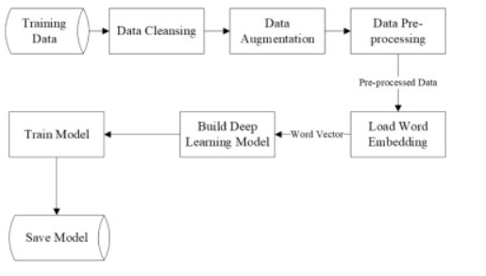

IV. DATASET USED

• We have downloaded two datasets named Fake, which consists of a list of articles considered fake news, and True, which consists of a list of articles considered real news. These news articles have been taken from Kaggle and contain news reports on diverse subjects. Further, we have used the data to train our machine-learning model. After that, we have done data pre-processing which is used before applying a machine learning algorithm to the model to make the raw data in a format suitable for input data for training. It is composed of data cleaning, transformation and reduction.
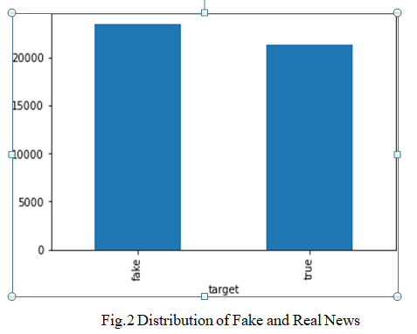

- In Data Pre-processing, firstly, we cleaned the data by removing all irrelevant and null values. We added labels as fake and true for the training of data. Then we removed punctuation from these news reports. We have done tokenization which means breaking down sentences into words. We tokenized the data and removed unnecessary, most frequently occurring words. Lastly, we removed stop words from filtering out unnecessary data. Stop words are those words which are abundantly found in the text and are of no use. For the above processes, we imported Python libraries such as NumPy, Pandas and Scikit-Learn.
- After that, we split the dataset into training and testing data. Here we divide the dataset as 80% for training and the rest 20% to test the model.
- Then Different classification models were trained to find the best accuracy in detecting fake news from these articles.

V. Classification Models

  - Logistic Regression
Logistic Regression is one of the supervised learning algorithms, i.e., a teacher or trainer is present to train the model.
In Logistic Regression, we classify the data according to our requirement and present the output in binary values such as true or false, which is transformed using a sigmoid function.
There are also various types of logistic regression functions such as Binomial, Multinomial and ordinal.
• Decision Tree
Decision tree has a tree like structure where every internal node represents a decision to be taken by this algorithm, each branch determines the result of that decision and the final classes are represented by leaf nodes. The path from root to leaf shows classification rule. It is used in ensemble learning and data mining for both regression and classification.
• Random Forest
It is a kind of ensemble learning algorithm that combines multiple decision trees. The idea behind using of random forest is to take combination of multiple decision trees, which minimize the chances of overfitting which is commonly found in decision trees. The Random forest algorithm makes multiple decision trees using random subset of training data and take the mean or majority vote of the prediction made by each individual trees for making last prediction. Random forest is usually used in regression and classification jobs. The Random forest is considered for producing highly accurate and robust results.

• Naïve Bayes Classifier
Naïve Bayes Classifier is a collection of classification algorithms based on Bayes Theorem which is used to determine the probability of an event with prior knowledge. The popular version of the algorithm is Gaussian Naïve Bayes used in classification task. It makes the prediction by scheming he expectations of the input data which is belonging to every class and then taking the class with maximum probability.in spite of this premise, the Naïve Bayes still perform good in exercising and used for spam filtering and classification.
• Support Vector Machine (SVM)
A support vector machine (SVM) is one of the popular machine learning algorithms used for classification and regression tasks. This algorithm finds the best decision boundary that separates or classify the data into different classes. It is chosen so that the distance between this hyperplane and the data points which are closest from this hyperplane is maximum.
Once the boundary is determined, new data can be classified by which side of the boundary it falls on. The applications of SVM have wide range such as image and text classification, bioinformatics, and natural language processing[8].
• Ensemble Learners
Ensemble learners are machine learning models that combine the predictions of multiple smaller models in order to improve the overall performance. There are variety of ways to do this, such as averaging the predictions, weighting the predictions based on the performance of each individual model, or training a meta-model to make a final prediction based on the outputs of the smaller models. Ensemble methods are often used in practice because they can lead to significant improvements in performance over a single model, especially in cases where the individual models have high bias or high variance[9].

VI. RESULTS

Initially we tested our dataset on Naïve Bayes classifier which gave an accuracy of 94.04%. The Logistic Regression Model performed well by giving an accuracy of 98.81%.

Random Forest Classifier performed closer to logistic regression model with an accuracy result of 98.51%. SVM and Decision Tree classifiers resulted in high accuracy with scores of 99.47% and 99.51%. These two models performed best among all and gave best results in accuracy.
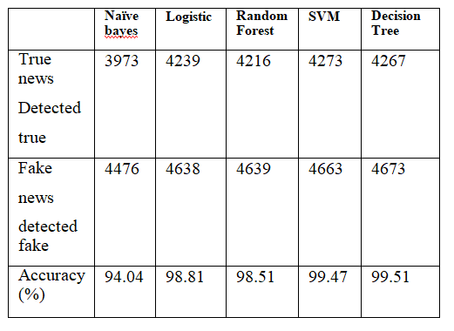
VII.Conclusion
In our research paper, we tried to solve the fake news problem using machine learning with ensemble-based approach to experiment with various algorithms instead of one so that we can achieve best accuracy. The dataset we used were news articles which belonged to a variety of subjects. Data pre-processing removed a significant number of characters and words from these articles resulting in filtered useful data which trained our machine learning models
The overall average accuracy performs comes out as 98% which is a good score. Among all the algorithms Decision Tree and SVM gave highest accuracies with more than 99% followed by Random Forest and Logistic Regression algorithms scoring more than 98% accuracy and the least performance was given by Naïve Bayes classifier with 94%. By this experiment it is clear that using machine learning as a solution to recognize fake articles is a success.
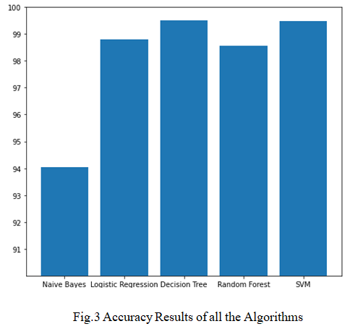

REFRENCES
- A. Douglas, “News consumption and the new electronic media,” The International Journal of Press/Politics, vol. 11, no. 1, pp. 29–52, 2006.

- J. Wong, “Almost all the traffic to fake news sites is from facebook, new data show,” 2016.

- D. M. J. Lazer, M. A. Baum, Y. Benkler et al., “The science of fake news,” Science, vol. 359, no. 6380, pp. 1094–1096, 2018.

- Can Machines Learn to Detect Fake News? A Survey Focused on Social Media Available at: https://scholarspace.manoa.hawaii.edu/handle/10125/59713.

- Johan Hovold. ”Naive bayes spam filtering using word-position-based attributes.” In CEAS, 2005.R. Nicole, “Title of paper with only first word capitalized,” J. Name Stand. Abbrev., in press.

- J. Hua and R. Shaw, “Corona virus (covid-19) “infodemic” and emerging issues through a data lens: the case of China,” International Journal of Environmental Research and Public Health, vol. 17, no. 7, p. 2309, 2020.

- H. Jwa, D. Oh, K. Park, J. M. Kang, and H. Lim, “exBAKE: automatic fake news detection model based on bidirectional encoder representations from transformers (bert),” Applied Sciences, vol. 9, no. 19, 2019.

- Bharath, G., Manikanta, K. J., Prakash, G. B., Sumathi, R., & Chinnasamy, P. (2021). Detecting Fake News Using Machine Learning Algorithms. 2021 International Conference on Computer Communication and Informatics (ICCCI).

- Kumar, S., Kumar, S., Yadav, P., & Bagri, M. (2021). A Survey on Analysis of Fake News Detection Techniques. 2021 International Conference on Artificial Intelligence and Smart Systems (ICAIS).

- D. S. K. R. Vivek Singh, Rupanjal Dasgupta and I. Ghosh, “Automated fake news detection using linguistic analysis and machine learning,” in International Conference on Social Computing, Behavioral-Cultural Modeling, & Prediction and Behavior Representation in Modeling and Simulation (SBPBRiMS), 2017

- Baarir, N. F., & Djeffal, A. (2021). Fake News detection Using Machine Learning. 2020 2nd International Workshop on Human-Centric Smart Environments for Health and Well-Being (IHSH).

